**Assignment:** Implements Layouts



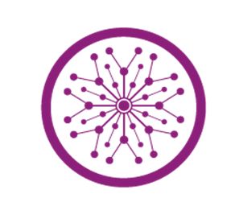

Assignment 1

MAD Theory

**Submitted by:** Iqra Khawar

**Submitted to:** Sir Muhammad Ahmad

**Section:** 6B

**Semester:** 6th

**Submission Deadline:** Coming Class

**Program:** SE

**Roll no:** su92-bssem-f22-307

**Department of Software Engineering**

Table of Contents

Implement Layout 1 2

Implemented Screen 1 2

Implemented Screen 2 3

Implemented Screen 3 4

Implement Layout 2 5

Implemented Screen 1 5

Implemented Screen 2 5

Implemented Screen 3 5

# 

# Implement Layout 1

## Implemented Screen 1

import 'package:flutter/material.dart';  
import 'scroll.dart';  
void main() {  
 runApp(const MyApp());  
}  
  
class MyApp extends StatelessWidget {  
 const MyApp({super.key});  
  
 @override  
 Widget build(BuildContext context) {  
 return MaterialApp(  
 debugShowCheckedModeBanner: false, // Optional: Removes debug banner  
 theme: ThemeData(  
 primarySwatch: Colors.*purple*,  
 scaffoldBackgroundColor: Colors.*purple*,  
 // Changes the primary color  
 // Background color  
 appBarTheme: const AppBarTheme(  
  
 ),  
 ),  
 home: const MyScreen(),  
 );  
 }  
}  
  
class MyScreen extends StatelessWidget {  
 const MyScreen({super.key});  
  
 @override  
 Widget build(BuildContext context) {  
 return Scaffold(  
 appBar: AppBar(  
 //title: const Text("My Home"),  
 backgroundColor: Colors.*purple* ,  
 ),  
  
 body:Center(  
 child:SingleChildScrollView(  
 child: Column(  
 children: [  
 Container(  
 child: Image.asset("images/hen.png" , width: 130, height: 130),  
 ),  
 Container(  
 width: 270,  
 height: 38,  
 decoration: BoxDecoration(  
 color: Colors.*white*,  
 borderRadius: BorderRadius.circular(30)  
  
 ),  
 child: Row(  
 mainAxisAlignment: MainAxisAlignment.spaceAround,  
 children: [  
 TextButton(onPressed: (){}, child: Text("Existing")),  
 TextButton(onPressed:(){  
 Navigator.*push*(  
 context,  
 MaterialPageRoute(builder: (context) => Scroller()),  
 );  
 } , child: Text("New Users",)),  
 ],  
 ),  
 ),  
 Container(  
 margin: EdgeInsets.only(top: 20),  
 padding: EdgeInsets.only(left: 4),  
 width: 300,  
 height: 270,  
 decoration: BoxDecoration(  
 color: Colors.*white*,  
 borderRadius: BorderRadius.circular(30),  
 boxShadow:[  
 BoxShadow(  
 color: Colors.*black*.withOpacity(0.3),  
 spreadRadius: 2, // How much the shadow spreads  
 blurRadius: 10, // How soft the shadow is  
 offset: Offset(4, 4)  
 )  
 ]  
 ),  
 child: Column(  
 mainAxisAlignment: MainAxisAlignment.center,  
 crossAxisAlignment: CrossAxisAlignment.center,  
 children: [  
 TextField(decoration: InputDecoration(  
 labelText: 'Username',  
 suffixIcon: Icon(Icons.*person*,color: Colors.*purpleAccent*),  
 )),  
 TextField(decoration: InputDecoration(  
 labelText: 'Email',  
 suffixIcon: Icon(Icons.*email*,color: Colors.*purpleAccent*),  
 )),  
 TextField(decoration: InputDecoration(  
 labelText: 'Password',  
 suffixIcon: Icon(Icons.*lock*, color: Colors.*purpleAccent*),  
 )),  
 TextField(decoration: InputDecoration(  
 labelText: 'Confirm Password',  
 suffixIcon: Icon(Icons.*lock*,color: Colors.*purpleAccent*),  
 )),  
  
 ],  
  
 ),  
   
 ),  
 //Button of Sign up  
 Container(  
 margin: EdgeInsets.only(bottom: 30),  
 decoration: BoxDecoration(  
 gradient: LinearGradient(  
 colors: [Colors.*purpleAccent*, Colors.*blueAccent*], // Blue to Purple Gradient  
 begin: Alignment.*bottomRight*,  
 end: Alignment.*bottomLeft*,  
 ),  
 borderRadius: BorderRadius.circular(30), // Rounded corners  
 ),  
 child: ElevatedButton(  
 onPressed: () {  
 print("Account created Successfully!");  
 },  
 style: ElevatedButton.*styleFrom*(  
 backgroundColor: Colors.*transparent*, // Transparent so gradient shows  
 shadowColor: Colors.*transparent*, // Remove default shadow  
 padding: EdgeInsets.symmetric(horizontal: 30, vertical: 15),  
 shape: RoundedRectangleBorder(  
 borderRadius: BorderRadius.circular(30),  
 ),  
 ),  
 child: Text(  
 "Sign Up",  
 style: TextStyle(  
 color: Colors.*white*, // White text color  
 fontSize: 15,  
 fontWeight: FontWeight.*bold*,  
 ),  
 ),  
 ),  
 ),  
 ]  
 ))  
  
 )  
 );  
 }  
}

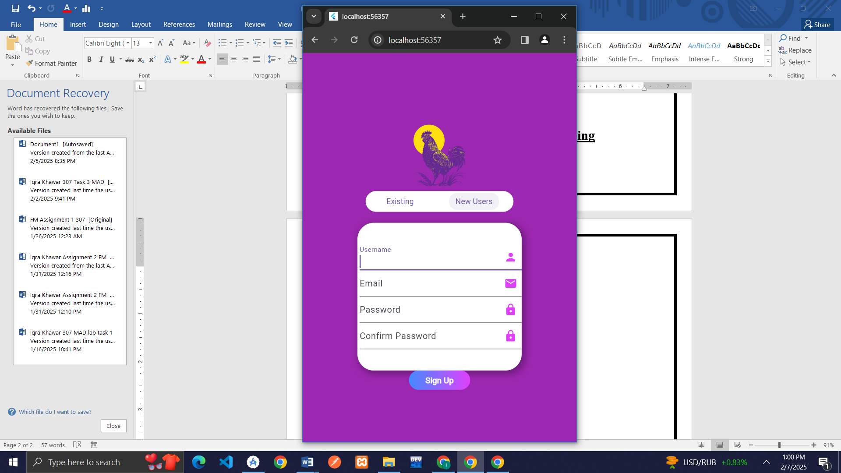

## Implemented Screen 2

import 'package:flutter/material.dart';  
import 'main.dart';  
  
void main() {  
 runApp(const MyApp());  
}  
  
class MyApp extends StatelessWidget {  
 const MyApp({super.key});  
  
 @override  
 Widget build(BuildContext context) {  
 return MaterialApp(  
 debugShowCheckedModeBanner: false, // Optional: Removes debug banner  
 theme: ThemeData(  
 primarySwatch: Colors.*purple*,  
 scaffoldBackgroundColor: Colors.*purple*,  
 // Changes the primary color  
 // Background color  
 appBarTheme: const AppBarTheme(backgroundColor: Colors.*purple*),  
 ),  
 home: const Scroller(),  
 );  
 }  
}  
  
class Scroller extends StatefulWidget {  
 const Scroller({super.key});  
 @override  
 _ScrollState createState() => _ScrollState();  
}  
  
class _ScrollState extends State<Scroller> {  
 void newUser() {  
 print("New user function called!");  
 }  
  
 @override  
 Widget build(BuildContext context) {  
 return Scaffold(  
 appBar: AppBar(  
 title: Text(""),  
 backgroundColor: Colors.*purple*,  
 ),  
 body: Center(  
 child: SingleChildScrollView(  
 child: Column(children: [  
 Container(  
 child: Image.asset("images/hen.png", width: 130, height: 130),  
 ),  
 Container(  
 width: 270,  
 height: 38,  
 decoration: BoxDecoration(  
 color: Colors.*white*, borderRadius: BorderRadius.circular(30)),  
 child: Row(  
 mainAxisAlignment: MainAxisAlignment.spaceAround,  
 children: [  
 TextButton(  
 onPressed: () {  
 Navigator.*push*(  
 context,  
 MaterialPageRoute(builder: (context) => MyScreen()),  
 );  
 },  
 child: Text("Existing")),  
 TextButton(  
 onPressed: () {},  
 child: Text(  
 "New Users",  
 )),  
 ],  
 ),  
 ),  
 Container(  
 margin: EdgeInsets.only(top: 30),  
 padding: EdgeInsets.only( left: 4),  
 width: 300,  
 height: 180,  
 decoration: BoxDecoration(  
 color: Colors.*white*, borderRadius: BorderRadius.circular(30),  
 boxShadow:[  
 BoxShadow(  
 color: Colors.*black*.withOpacity(0.3),  
 spreadRadius: 2, // How much the shadow spreads  
 blurRadius: 10, // How soft the shadow is  
 offset: Offset(4, 4)  
 )  
 ]  
 ),  
  
 child: Column(  
 mainAxisAlignment: MainAxisAlignment.center,  
 crossAxisAlignment: CrossAxisAlignment.center,  
 children: [  
 TextField(  
 decoration: InputDecoration(  
 labelText: 'Username',  
 suffixIcon: Icon(Icons.*person*, color: Colors.*purpleAccent*),  
 )),  
 TextField(  
 decoration: InputDecoration(  
 labelText: 'Password',  
 suffixIcon: Icon(Icons.*lock*, color: Colors.*purpleAccent*),  
 )),  
 ],  
 ),  
 ),  
 Container(  
 margin: EdgeInsets.only(bottom: 12),  
 decoration: BoxDecoration(  
 gradient: LinearGradient(  
 colors: [  
 Colors.*purpleAccent*, Colors.*blueAccent* ], // Blue to Purple Gradient  
 begin: Alignment.*bottomRight*,  
 end: Alignment.*bottomLeft*,  
 ),  
 borderRadius: BorderRadius.circular(30), // Rounded corners  
 ),  
 child: ElevatedButton(  
 onPressed: () {  
 print("Login Successful!");  
 },  
 style: ElevatedButton.*styleFrom*(  
 backgroundColor:  
 Colors.*transparent*, // Transparent so gradient shows  
 shadowColor: Colors.*transparent*, // Remove default shadow  
 padding: EdgeInsets.symmetric(horizontal: 30, vertical: 15),  
 shape: RoundedRectangleBorder(  
 borderRadius: BorderRadius.circular(30),  
 ),  
 ),  
 child: Text(  
 "Login",  
 style: TextStyle(  
 color: Colors.*white*, // White text color  
 fontSize: 15,  
 fontWeight: FontWeight.*bold*,  
 ),  
 ),  
 ),  
 ),  
 Container(  
 margin: EdgeInsets.only(top: 23),  
 child: Text("Forgot Password?",  
 style: TextStyle(fontSize: 14, color: Colors.*white*)),  
 ),  
 Row(  
 children: [  
 Expanded(  
 child: Divider(  
 color: Colors.*white*,  
 thickness: 2,  
 indent: 50,  
 endIndent: 2,  
 ),  
 ),  
 Padding(  
 padding:  
 EdgeInsets.symmetric(horizontal: 8), // Space around "OR"  
 child: Text(  
 "OR",  
 style: TextStyle(  
 color: Colors.*white*,  
 fontSize: 16,  
 fontWeight: FontWeight.*bold*),  
 ),  
 ),  
 Expanded(  
 child: Divider(  
 color: Colors.*white*,  
 indent: 2,  
 endIndent: 50,  
 thickness: 2,  
 ),  
 ),  
 ],  
 ),  
 Row(  
 mainAxisAlignment: MainAxisAlignment.center,  
 crossAxisAlignment: CrossAxisAlignment.center,  
 children: [  
 Container(  
 margin: EdgeInsets.only(right: 23),  
 child: Image.asset(  
 "images/facebook.png",  
 width: 30,  
 height: 30,  
 ),  
 ),  
 Container(  
 child: Image.asset(  
 "images/search.png",  
 width: 30,  
 height: 30,  
 ),  
 )  
 ],  
 )  
 ]))));  
 }  
}

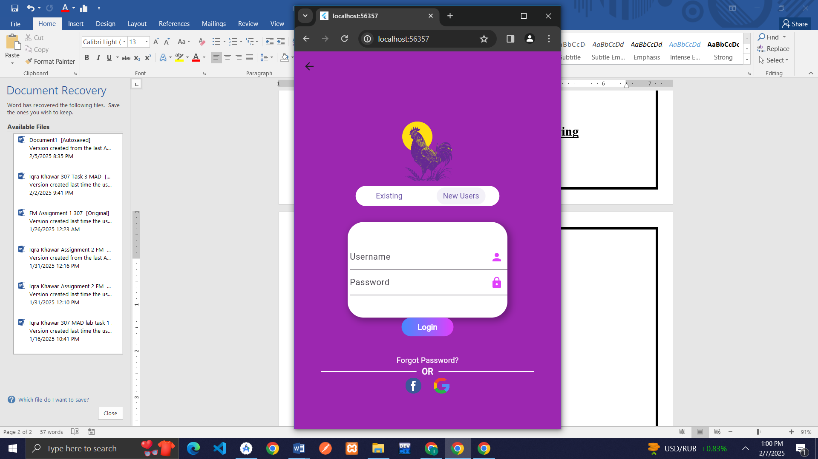

## Implemented Screen 3

import 'package:flutter/material.dart';  
  
  
void main() {  
 runApp(MyApp());  
}  
  
class MyApp extends StatelessWidget {  
 @override  
 Widget build(BuildContext context) {  
 return MaterialApp(  
 home: Scaffold(  
 backgroundColor: Colors.*white*,  
 // appBar: AppBar(  
 // backgroundColor: Colors.purpleAccent,  
 //  
 // centerTitle: true,  
 // ),  
 body: Stack(  
 alignment: Alignment.*topCenter*,  
 children: [  
  
 Container(  
 margin: EdgeInsets.only(),  
 width: 500,  
 height: 80,  
 // color: Colors.purpleAccent,  
 decoration: BoxDecoration(  
 color: Colors.*purpleAccent*,  
 borderRadius: BorderRadius.only(bottomLeft: Radius.circular(43),bottomRight: Radius.circular(43)),  
 boxShadow:[  
 BoxShadow(  
 color: Colors.*black*.withOpacity(0.3),  
 spreadRadius: 2, // How much the shadow spreads  
 blurRadius: 10, // How soft the shadow is  
 offset: Offset(4, 4)  
 )  
 ]  
 ),  
  
 child:Row(  
 mainAxisAlignment: MainAxisAlignment.center,  
 children: [  
 Container(  
 margin:EdgeInsets.only(right: 120),  
 child: Icon(Icons.*person*,color: Colors.*white*,),  
 ),  
 Container(  
 //margin:EdgeInsets.only(left: 60),  
 child: Text("Sobat Ternak",style: TextStyle(fontWeight: FontWeight.*bold*,color: Colors.*white*),),  
 ),  
 Container(  
 margin:EdgeInsets.only(left: 120),  
 child: Icon(Icons.*message*,color: Colors.*white*,),  
 )  
  
 ],  
 )  
 ),  
  
 Container(  
 margin: EdgeInsets.only(top: 70),  
 width: 370,  
 height: 160,  
 //color: Colors.white,  
 decoration: BoxDecoration(  
 borderRadius: BorderRadius.circular(13),  
 color: Colors.*white*,  
 boxShadow:[  
 BoxShadow(  
  
 color: Colors.*black*.withOpacity(0.3),  
 spreadRadius: 2, // How much the shadow spreads  
 blurRadius: 10, // How soft the shadow is  
 offset: Offset(4, 4)  
 )  
 ]  
 ),  
 child: Row(  
 crossAxisAlignment: CrossAxisAlignment.start,  
 mainAxisAlignment: MainAxisAlignment.spaceBetween,  
 children: [  
 Container(  
 margin:EdgeInsets.only(bottom: 6,left: 35),  
 child: Text("Items Price", style: TextStyle(color: Colors.*black54*, fontWeight: FontWeight.*bold*),),  
 ),  
 Container(  
 margin: EdgeInsets.only(bottom: 6, right: 35),  
 child: Row(  
 mainAxisSize: MainAxisSize.min, // Only take the required space  
 children: [  
 Text(  
 "Today",  
 style: TextStyle(  
 color: Colors.*black54*,  
 fontWeight: FontWeight.*bold*,  
 ),  
 ),  
 SizedBox(width: 8), // Space between text and icon  
 Icon(  
 Icons.*calendar_today*, // Choose your preferred icon  
 color: Colors.*black54*,  
 size: 20,  
 ),  
 ],  
 ),  
 ),  
  
 ],  
 ),  
  
  
 ),  
 Column(  
 mainAxisAlignment: MainAxisAlignment.center,  
 crossAxisAlignment: CrossAxisAlignment.center,  
 children: [  
 Container(  
 margin: EdgeInsets.only(bottom: 450),  
 width:350,  
 height:70,  
 color: Colors.*white*,  
 child: Row(  
 mainAxisAlignment: MainAxisAlignment.spaceBetween,  
 crossAxisAlignment: CrossAxisAlignment.center,  
 children: [  
 Container(  
 margin:EdgeInsets.only(),  
 child: Column(  
 children: [  
 Container(  
 child: Image.asset("images/q1.jpg", width: 50, height: 50),  
 ),  
 Container(  
 child: Text("22,000", style: TextStyle(color: Colors.*orange*,fontWeight: FontWeight.*bold*),),  
 )  
 ],  
 ),  
 ),  
 Container(  
 child: Column(  
 children: [  
 Container(  
 child: Image.asset("images/q3.jpg", width: 50, height: 50),  
 ),  
 Container(  
 child: Text("22,000", style: TextStyle(color: Colors.*orange*,fontWeight: FontWeight.*bold*),),  
 )  
 ],  
 ),  
 ),  
 Container(  
 child: Column(  
 children: [  
 Container(  
 child: Image.asset("images/q7.jpg", width: 50, height: 50),  
 ),  
 Container(  
 child: Text("22,000", style: TextStyle(color: Colors.*orange*,fontWeight: FontWeight.*bold*),),  
 )  
 ],  
 ),  
 ),  
 Container(  
 child: Column(  
 children: [  
 Container(  
 child: Image.asset("images/q5.jpg", width: 50, height: 50),  
 ),  
 Container(  
 child: Text("22,000", style: TextStyle(color: Colors.*orange*,fontWeight: FontWeight.*bold*),),  
 )  
 ],  
 ),  
 ),  
 Container(  
 child: Column(  
 children: [  
 Container(  
 child: Image.asset("images/q8.jpg", width: 50, height: 50),  
 ),  
 Container(  
 child: Text("22,000", style: TextStyle(color: Colors.*orange*,fontWeight: FontWeight.*bold*),),  
 )  
 ],  
 ),  
 ),  
  
 ],  
 ),  
 ),  
  
 ],  
 ),  
 Row(  
 mainAxisAlignment: MainAxisAlignment.center,  
 children: [  
 Container(  
 margin: EdgeInsets.only(top:187),  
 child: Column(  
 children: [  
 Container(  
 child: Icon(Icons.*thumb_up_rounded*,color: Colors.*grey*),  
 ),  
 Container(  
 child:Text("Like",style: TextStyle(color: Colors.*grey*, fontWeight: FontWeight.*bold*),)  
 )  
 ],  
 ),  
 ),  
 Container(  
 margin: EdgeInsets.only(top:187,left: 76),  
 child: Column(  
 children: [  
 Container(  
 child: Icon(Icons.*comment*,color: Colors.*grey*),  
 ),  
 Container(  
 child:Text("Comment",style: TextStyle(color: Colors.*grey*, fontWeight: FontWeight.*bold*),)  
 )  
 ],  
 ),  
 ),  
 Container(  
 margin: EdgeInsets.only(top:187,left: 76),  
 child: Column(  
 children: [  
 Container(  
 child: Icon(Icons.*send*,color: Colors.*grey*),  
 ),  
 Container(  
 child:Text("Share",style: TextStyle(color: Colors.*grey*, fontWeight: FontWeight.*bold*),)  
 )  
 ],  
 ),  
 )  
 ],  
 ),  
 Row(  
 mainAxisAlignment: MainAxisAlignment.center,  
  
 children: [  
 Container(  
 margin: EdgeInsets.only(top:259  
 ),  
 child: Text("Latest Product" ,style:TextStyle(fontSize: 15,color: Colors.*grey*,fontWeight: FontWeight.*bold*)),  
 ),  
 Container(  
 margin: EdgeInsets.only(top:259,left: 190  
 ),  
 child: Text("View All" ,style:TextStyle(color: Colors.*grey*)),  
 )  
 ],  
 ),  
 Row(  
 mainAxisAlignment: MainAxisAlignment.spaceAround,  
  
 children: [  
 Container(  
 margin: EdgeInsets.only(top:300),  
 child: Column(  
 children: [  
 Container(  
 // child: Image.asset("images/pl1.jpg",width: 80, height: 80,),  
 child: ClipRRect(  
 borderRadius: BorderRadius.circular(40), // Half of width/height to make it circular  
 child: Image.asset(  
 "images/pl1.jpg",  
 width: 80,  
 height: 80,  
 fit: BoxFit.cover, // Ensures the image covers the circular area  
 ),  
 ),  
 ),  
 Container(  
 child: Text("Plant Frame",style: TextStyle(color: Colors.*black54*, fontWeight: FontWeight.*bold*)),  
 ),  
 Container(  
 child: Text("28000",style: TextStyle(color: Colors.*blueAccent*, fontWeight: FontWeight.*bold*)),  
 )  
 ],  
 ),  
 ),  
 Container(  
 margin: EdgeInsets.only(top:300),  
 child: Column(  
 children: [  
 Container(  
 // child: Image.asset("images/pl1.jpg",width: 80, height: 80,),  
 child: ClipRRect(  
 borderRadius: BorderRadius.circular(40), // Half of width/height to make it circular  
 child: Image.asset(  
 "images/pl2.jpg",  
 width: 80,  
 height: 80,  
 fit: BoxFit.cover, // Ensures the image covers the circular area  
 ),  
 ),  
 ),  
 Container(  
 child: Text("Plant Frame",style: TextStyle(color: Colors.*black54*, fontWeight: FontWeight.*bold*)),  
 ),  
 Container(  
 child: Text("38000",style: TextStyle(color: Colors.*blueAccent*, fontWeight: FontWeight.*bold*)),  
 )  
 ],  
 ),  
 ),  
 Container(  
 margin: EdgeInsets.only(top:300),  
 child: Column(  
 children: [  
 Container(  
 // child: Image.asset("images/pl1.jpg",width: 80, height: 80,),  
 child: ClipRRect(  
 borderRadius: BorderRadius.circular(40), // Half of width/height to make it circular  
 child: Image.asset(  
 "images/pl3.jpg",  
 width: 80,  
 height: 80,  
 fit: BoxFit.cover, // Ensures the image covers the circular area  
 ),  
 ),  
 ),  
 Container(  
 child: Text("Plant Frame",style: TextStyle(color: Colors.*black54*, fontWeight: FontWeight.*bold*)),  
 ),  
 Container(  
 child: Text("68000",style: TextStyle(color: Colors.*blueAccent*, fontWeight: FontWeight.*bold*)),  
 )  
 ],  
 ),  
 ),  
 Container(  
 margin: EdgeInsets.only(top:300),  
 child: Column(  
 children: [  
 Container(  
 // child: Image.asset("images/pl1.jpg",width: 80, height: 80,),  
 child: ClipRRect(  
 borderRadius: BorderRadius.circular(40), // Half of width/height to make it circular  
 child: Image.asset(  
 "images/pl4.jpg",  
 width: 80,  
 height: 80,  
 fit: BoxFit.cover, // Ensures the image covers the circular area  
 ),  
 ),  
 ),  
 Container(  
 child: Text("Plant Frame",style: TextStyle(color: Colors.*black54*, fontWeight: FontWeight.*bold*)),  
 ),  
 Container(  
 child: Text("58000",style: TextStyle(color: Colors.*blueAccent*, fontWeight: FontWeight.*bold*)),  
 )  
 ],  
 ),  
 )  
 ],  
 ),  
 Row(  
 mainAxisAlignment: MainAxisAlignment.spaceEvenly,  
 children: [  
 Container(  
 margin: EdgeInsets.only(top:230),  
 child: ClipRRect(  
 borderRadius: BorderRadius.circular(40), // Half of width/height to make it circular  
 child: Image.asset(  
 "images/b1.jpg",  
 width: 100,  
 height: 100,  
 fit: BoxFit.cover, // Ensures the image covers the circular area  
 ),  
 ),  
 ),  
 Container(  
 margin: EdgeInsets.only(top:440),  
 child:Column(  
 children: [  
 Container(  
 child: Align(  
 alignment: Alignment.*centerLeft*, // Left align text  
 child: Text(  
 "Martin Paimer",  
 style: TextStyle(fontWeight: FontWeight.*bold*, fontSize: 15),  
 ),  
 )  
 ),  
 Container(  
 child: Align(  
 alignment: Alignment.*centerLeft*, // Left align text  
 child: Text(  
 "Just now",  
 style: TextStyle(color:Colors.*grey*,fontWeight: FontWeight.*w100*, fontSize: 15),  
 ),  
 )  
 ),  
 Container(  
 child: Align(  
 alignment: Alignment.*centerLeft*, // Left align text  
 child: Text(  
 "Lorem ipsum is a dumy text",  
 style: TextStyle(color:Colors.*grey*,fontWeight: FontWeight.*bold*, fontSize: 15),  
 ),  
 )  
 ),  
  
 Container(  
 child: Image.asset("images/baby.jpg",width: 400, height: 200)  
 ),  
  
 ],  
 )  
 )  
 ],  
 ),  
 Row(  
  
 children: [  
 Container(  
 margin: EdgeInsets.only(top:660),  
 width: 500,  
 height: 50,  
 color:Colors.*white*,  
 child: Row(  
 mainAxisAlignment: MainAxisAlignment.spaceAround,  
 children: [  
 Container(  
 child:Icon(Icons.*home*,color: Colors.*purple*,)  
 ),  
 Container(  
 child:Icon(Icons.*list_alt*,color: Colors.*blueGrey*,)  
 ),  
 Container(  
 child:Icon(Icons.*add*,color: Colors.*blueGrey*,)  
 ),  
 Container(  
 child:Icon(Icons.*library_books_sharp*,color: Colors.*blueGrey*,)  
 ),  
 Container(  
 child:Icon(Icons.*notifications*,color: Colors.*blueGrey*,)  
 )  
 ],  
 ),  
 )  
 ],  
 )  
 ]  
 )  
  
  
 ),  
  
  
 );  
  
  
 }  
}

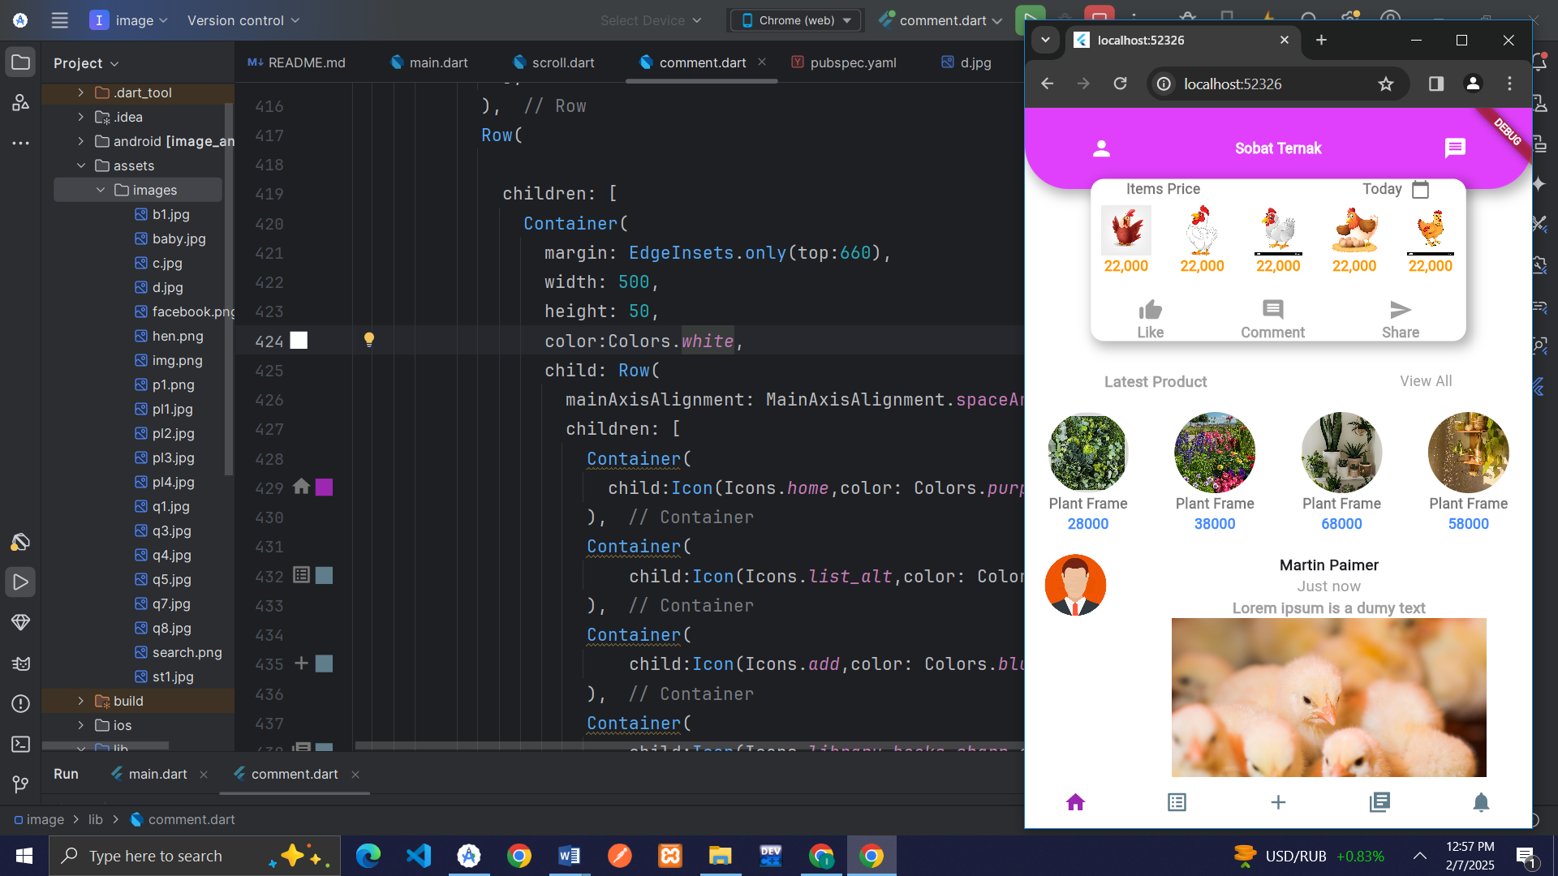

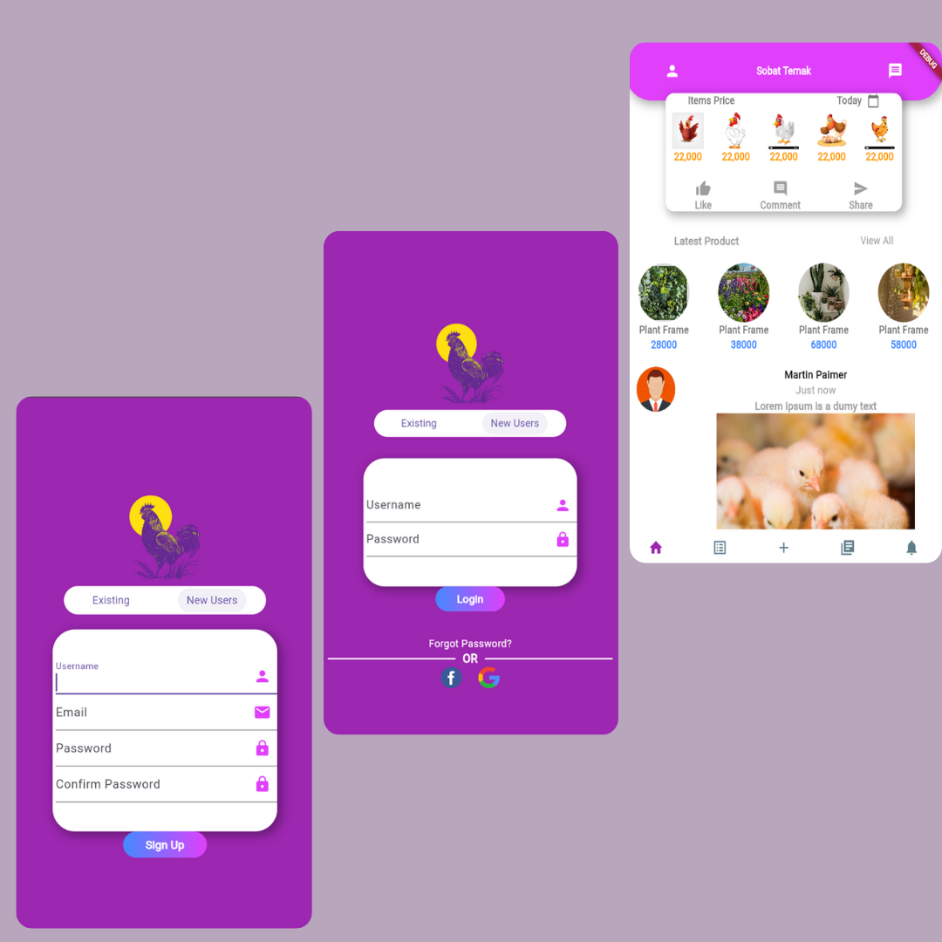

# Implement Layout 2

## Implemented Screen 1

import 'package:flutter/material.dart';  
  
//Layout 2  
//Screen 1  
void main() {  
 runApp(MyApp());  
}  
  
class MyApp extends StatelessWidget {  
 @override  
 Widget build(BuildContext context) {  
 return MaterialApp(  
  
 debugShowCheckedModeBanner: false,  
 home: Scaffold(  
 appBar: AppBar(  
backgroundColor: Colors.*white*,  
 centerTitle: true,  
 ),  
 body:Center(  
 child:SingleChildScrollView(  
 child:Column(  
 mainAxisAlignment: MainAxisAlignment.center,  
 crossAxisAlignment: CrossAxisAlignment.center,  
 children: [  
 Container(  
 child: Image.asset("images/h7.png",width: 300,height: 300,),  
 ),  
 Container(  
 width: 1600,  
 height: 850,  
 decoration: BoxDecoration(  
 borderRadius: BorderRadius.only(topLeft: Radius.circular(35),topRight: Radius.circular(35)),  
 color: Colors.*green*,  
 ),  
 child: Column(  
  
 children: [  
 Container(  
 padding: EdgeInsets.all(23),  
 child: Row(  
 children: [  
 Icon(Icons.*person*,color: Colors.*white*),  
 SizedBox(width: 10),  
 Expanded(child: TextField(  
 decoration: InputDecoration(  
 hintText: "Username",  
 hintStyle: TextStyle(color: Colors.*white70*),  
 ),  
 ))  
  
 ],  
 ),  
 ),  
 Container(  
 padding: EdgeInsets.all(23),  
 child: Row(  
 children: [  
 Icon(Icons.*lock*,color: Colors.*white*),  
 SizedBox(width: 10),  
 Expanded(child: TextField(  
 decoration: InputDecoration(  
 hintText: "Password",  
 hintStyle: TextStyle(color: Colors.*white70*),  
 ),  
 ))  
  
 ],  
 ),  
 ),  
 Container(  
 child: Text("Forgot Password?",textAlign:TextAlign.center,style: TextStyle(color: Colors.*white*),),  
 ),  
 Container(  
 padding:EdgeInsets.all(22),  
 decoration: BoxDecoration(  
 borderRadius: BorderRadius.all(Radius.circular(15)),  
 ),  
 child: OutlinedButton(onPressed: (){}, style: OutlinedButton.*styleFrom*(  
 backgroundColor: Colors.*white*, // Button ka background color  
 foregroundColor: Colors.*blueGrey*, // Text color  
 // side: BorderSide(color : Colors.blueAccent), // Border color  
 padding: EdgeInsets.symmetric(vertical: 19, horizontal: 100), // Button padding  
 ), child: Text("Sign in"))),  
 Container(  
 child: Row(  
 mainAxisAlignment: MainAxisAlignment.center,  
 children: [  
 Container(  
 margin:EdgeInsets.all(12),  
 child: Text("New User",style: TextStyle(color: Colors.*white*),),  
 ),  
 Container(  
 child: Text("Sign up", style: TextStyle(color: Colors.*white*),),  
 )  
 ],  
 ),  
 )  
  
 ],  
 ),  
 ),  
  
 ],  
 ),  
 )  
 )  
  
  
  
  
 ),  
  
  
 );  
  
  
 }  
}

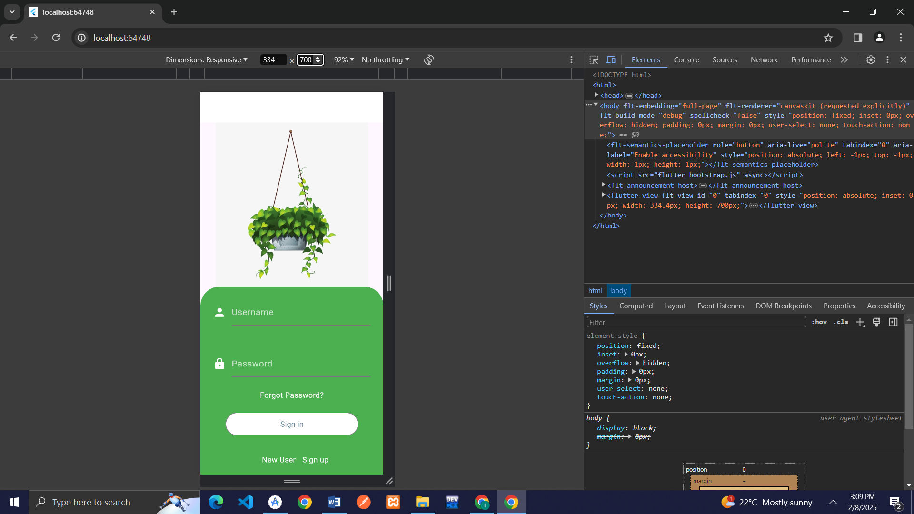

## Implemented Screen 2

import 'package:flutter/material.dart';  
  
//Layout 2  
//Screen 2  
void main() {  
 runApp(MyApp());  
}  
  
class MyApp extends StatelessWidget {  
 @override  
 Widget build(BuildContext context) {  
 return MaterialApp(  
  
 debugShowCheckedModeBanner: false,  
 theme: ThemeData(  
 //primarySwatch: Colors.purple,  
 scaffoldBackgroundColor: Colors.*white*,  
 // Changes the primary color  
 // Background color  
 appBarTheme: const AppBarTheme(  
  
 ),  
 ),  
 home: Scaffold(  
 appBar: AppBar(  
backgroundColor: Colors.*white*,  
 centerTitle: true,  
 ),  
 body: Center(  
child:SingleChildScrollView(  
 child: Column(  
 children: [  
 Container(  
 padding:EdgeInsets.only(left: 24,right: 24,bottom: 12),  
 child: Row(  
 mainAxisAlignment: MainAxisAlignment.spaceBetween,  
 children: [  
 Container(  
 child: Icon(Icons.*menu*,color: Colors.*grey*),  
 ),  
  
 Container(  
 child: Icon(Icons.*shopping_cart*,color: Colors.*grey*,),  
 )  
 ],  
 ),  
 ),  
 Align(  
 alignment:Alignment.*centerLeft*,  
 child: Container(  
 margin: EdgeInsets.only(left: 23),  
 child: Text("What kind of",textAlign:TextAlign.left,style: TextStyle(color: Colors.*black*,fontSize:17,fontWeight: FontWeight.*bold*)),  
 ),  
 ),  
 Align(  
 alignment:Alignment.*centerLeft*,  
 child: Container(  
 margin: EdgeInsets.only(left: 23),  
 child: Text("Plant do you want?",textAlign:TextAlign.left,style: TextStyle(color: Colors.*black*,fontSize:17,fontWeight: FontWeight.*bold*)),  
 ),  
 ),  
 Container(  
 padding:EdgeInsets.all(23),  
 child:SingleChildScrollView(  
 scrollDirection: Axis.horizontal,  
 child: Row(  
 mainAxisAlignment: MainAxisAlignment.center,  
 crossAxisAlignment: CrossAxisAlignment.center,  
 children: [  
 Container(  
 padding: EdgeInsets.only(left: 5,right: 5),  
 decoration: BoxDecoration(  
 borderRadius: BorderRadius.all(Radius.circular(4)),  
 color: Colors.*grey*,  
  
 ),  
 width: 300,  
 height: 30,  
child:SingleChildScrollView(  
 scrollDirection: Axis.horizontal,  
  
 child: Row(  
 mainAxisAlignment: MainAxisAlignment.spaceBetween,  
 children: [  
 Container(  
  
 child: Icon(Icons.*search*,color: Colors.*white*),  
 ),  
 Container(  
  
 child: Text("Search",style: TextStyle(color: Colors.*black54*),),  
 ),  
 Container(  
 margin:EdgeInsets.only(left: 190),  
 child: Icon(Icons.*mic*,color: Colors.*white*),  
 ),  
  
 ],  
 ),  
 ),  
 ),  
 ],  
 ),  
 ),  
 ),  
 Container(  
 margin: EdgeInsets.only(top: 8,bottom: 10),  
 child: Row(  
 mainAxisAlignment: MainAxisAlignment.spaceEvenly,  
 children: [  
 Container(  
 child: Text("All",style: TextStyle(color: Colors.*black38*,fontSize: 16),),  
 ),  
 Container(  
 child: Text("Small",style: TextStyle(color: Colors.*black38*,fontSize: 16),),  
 ),  
 Container(  
 child: Text("Medium",style: TextStyle(color: Colors.*black38*,fontSize: 16),),  
 ),  
 Container(  
 child: Text("Hanging",style: TextStyle(color: Colors.*black38*,fontSize: 16),),  
 )  
 ],  
 ),  
 ),  
 Container(  
 child:SingleChildScrollView(  
 scrollDirection: Axis.horizontal,  
 child: Row(  
 mainAxisAlignment: MainAxisAlignment.spaceBetween,  
 children: [  
 Container(  
 margin: EdgeInsets.only(right: 12),  
 decoration: BoxDecoration(  
 borderRadius: BorderRadius.all(Radius.circular(18)),  
 color:Colors.*green*,  
 ),  
 width: 160,  
 height: 220,  
 child: Column(  
 children: [  
 Container(  
 margin:EdgeInsets.only(top:23),  
 child: Row(  
 mainAxisAlignment: MainAxisAlignment.spaceAround,  
 children: [  
 Container(  
 child: Text("In door",style: TextStyle(color: Colors.*white*)),  
 ),  
 Container(  
 child: Image.asset("images/heart.png",width: 20,height: 20,),  
 ),  
 ],  
 ),  
 ),  
 Container(  
 margin: EdgeInsets.all(16),  
 child: Image.asset("images/bg2.jpg",width: 100,height: 80,),  
 ),  
 Container(  
 margin: EdgeInsets.only(left: 5,right: 5),  
 child: Row(  
 mainAxisAlignment: MainAxisAlignment.spaceBetween,  
 children: [  
 Container(  
 child: Column(  
 mainAxisAlignment: MainAxisAlignment.end,  
 children: [  
 Container(  
 child: Text("Ficas",style: TextStyle(color: Colors.*white*,fontSize: 17,fontWeight: FontWeight.*bold*)),  
 ),  
 Container(  
 child: Text("From PKR 120",style: TextStyle(color: Colors.*white*,fontSize: 12,fontWeight: FontWeight.*w100*)),  
 ),  
 ],  
 ),  
 ),  
 Container(  
 child: Image.asset("images/add-button.png",width: 30,height: 30),  
 )  
 ],  
 ),  
 )  
 ],  
  
 ),  
 ),  
 Container(  
 // margin: EdgeInsets.all(30),  
 decoration: BoxDecoration(  
 borderRadius: BorderRadius.all(Radius.circular(18)),  
 color:Colors.*green*,  
 ),  
 width: 160,  
 height: 220,  
 child: Column(  
 children: [  
 Container(  
 margin:EdgeInsets.only(top:23),  
 child: Row(  
 mainAxisAlignment: MainAxisAlignment.spaceAround,  
 children: [  
 Container(  
 child: Text("In door",style: TextStyle(color: Colors.*white*)),  
 ),  
 Container(  
 child: Image.asset("images/heart.png",width: 20,height: 20,),  
 ),  
 ],  
 ),  
 ),  
 Container(  
 margin: EdgeInsets.all(16),  
 child: Image.asset("images/bg3.jpg",width: 100,height: 80,),  
 ),  
 Container(  
 margin: EdgeInsets.only(left: 5,right: 5),  
 child: Row(  
 mainAxisAlignment: MainAxisAlignment.spaceBetween,  
 children: [  
 Container(  
 child: Column(  
 mainAxisAlignment: MainAxisAlignment.end,  
 children: [  
 Container(  
 child: Text("Cactus",style: TextStyle(color: Colors.*white*,fontSize: 17,fontWeight: FontWeight.*bold*)),  
 ),  
 Container(  
 child: Text("From PKR 120",style: TextStyle(color: Colors.*white*,fontSize: 12,fontWeight: FontWeight.*w100*)),  
 ),  
 ],  
 ),  
 ),  
 Container(  
 child: Image.asset("images/add-button.png",width: 30,height: 30),  
 )  
 ],  
 ),  
 )  
 ],  
  
 ),  
 ),  
 ],  
 ),  
 ),  
 ),  
 //Container portion 2  
 Container(  
 margin: EdgeInsets.only(top:20),  
 child:SingleChildScrollView(  
 scrollDirection: Axis.horizontal,  
  
 child: Row(  
 mainAxisAlignment: MainAxisAlignment.spaceAround,  
 children: [  
 Container(  
 margin: EdgeInsets.only(right: 12),  
 decoration: BoxDecoration(  
 borderRadius: BorderRadius.all(Radius.circular(18)),  
 color:Colors.*green*,  
 ),  
 width: 160,  
 height: 220,  
 child: Column(  
 children: [  
 Container(  
 margin:EdgeInsets.only(top:23),  
 child: Row(  
 mainAxisAlignment: MainAxisAlignment.spaceAround,  
 children: [  
 Container(  
 child: Text("In door",style: TextStyle(color: Colors.*white*)),  
 ),  
 Container(  
 child: Image.asset("images/heart.png",width: 20,height: 20,),  
 ),  
 ],  
 ),  
 ),  
 Container(  
 margin: EdgeInsets.all(16),  
 child: Image.asset("images/bg5.jpg",width: 100,height: 90,),  
 ),  
 Container(  
 margin: EdgeInsets.only(left: 5,right: 5),  
 child: Row(  
 mainAxisAlignment: MainAxisAlignment.spaceBetween,  
 children: [  
 Container(  
 child: Column(  
 mainAxisAlignment: MainAxisAlignment.end,  
 children: [  
 Container(  
 child: Text("Samantha",style: TextStyle(color: Colors.*white*,fontSize: 17,fontWeight: FontWeight.*bold*)),  
 ),  
 Container(  
 child: Text("From PKR 120",style: TextStyle(color: Colors.*white*,fontSize: 12,fontWeight: FontWeight.*w100*)),  
 ),  
 ],  
 ),  
 ),  
 Container(  
 child: Image.asset("images/add-button.png",width: 30,height: 30),  
 )  
 ],  
 ),  
 )  
 ],  
  
 ),  
 ),  
 Container(  
 // margin: EdgeInsets.all(30),  
 decoration: BoxDecoration(  
 borderRadius: BorderRadius.all(Radius.circular(18)),  
 color:Colors.*green*,  
 ),  
 width: 160,  
 height: 220,  
 child: Column(  
 children: [  
 Container(  
 margin:EdgeInsets.only(top:23),  
 child: Row(  
 mainAxisAlignment: MainAxisAlignment.spaceAround,  
 children: [  
 Container(  
 child: Text("In door",style: TextStyle(color: Colors.*white*)),  
 ),  
 Container(  
 child: Image.asset("images/heart.png",width: 20,height: 20,),  
 ),  
 ],  
 ),  
 ),  
 Container(  
 margin: EdgeInsets.all(16),  
 child: Image.asset("images/bg6.jpg",width: 190,height: 90,),  
 ),  
 Container(  
 margin: EdgeInsets.only(left: 5,right: 5),  
 child: Row(  
 mainAxisAlignment: MainAxisAlignment.spaceBetween,  
 children: [  
 Container(  
 child: Column(  
 mainAxisAlignment: MainAxisAlignment.end,  
 children: [  
 Container(  
 child: Text("Alovera",style: TextStyle(color: Colors.*white*,fontSize: 17,fontWeight: FontWeight.*bold*)),  
 ),  
 Container(  
 child: Text("From PKR 120",style: TextStyle(color: Colors.*white*,fontSize: 12,fontWeight: FontWeight.*w100*)),  
 ),  
 ],  
 ),  
 ),  
 Container(  
 child: Image.asset("images/add-button.png",width: 30,height: 30),  
 )  
 ],  
 ),  
 )  
 ],  
  
 ),  
 ),  
 ],  
 ),  
 )  
 )  
 ],  
 ),  
 ),  
 )  
 )  
  
  
  
  
  
  
  
 );  
  
  
 }  
}

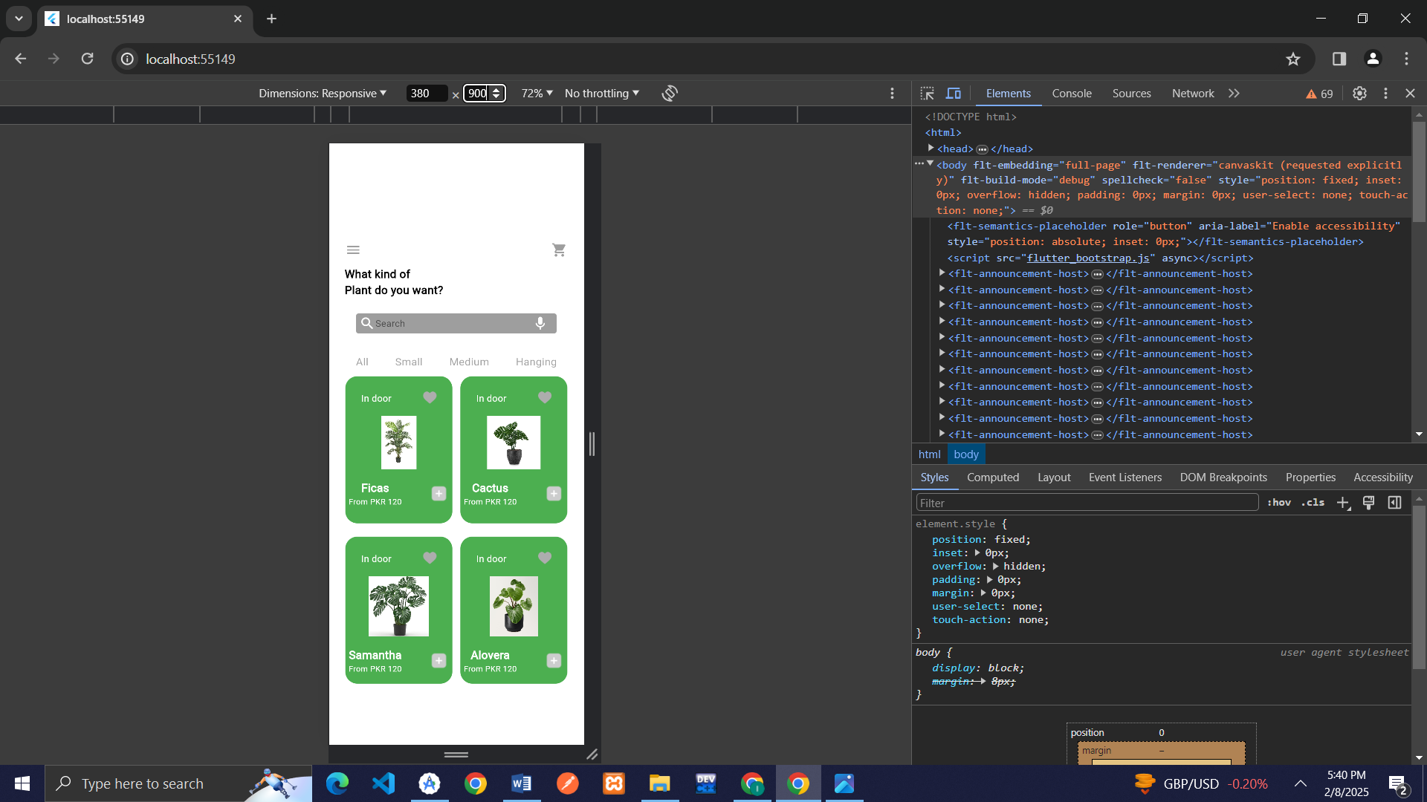

## Implemented Screen 3

import 'package:flutter/material.dart';  
  
//Layout 3  
//Screen 3  
void main() {  
 runApp(MyApp());  
}  
  
class MyApp extends StatelessWidget {  
 @override  
 Widget build(BuildContext context) {  
 return MaterialApp(  
  
 debugShowCheckedModeBanner: false,  
 theme: ThemeData(  
 //primarySwatch: Colors.purple,  
 scaffoldBackgroundColor: Colors.*white*,  
 // Changes the primary color  
 // Background color  
 appBarTheme: const AppBarTheme(  
  
 ),  
 ),  
 home: Scaffold(  
 appBar: AppBar(  
backgroundColor: Colors.*white*,  
 centerTitle: true,  
 ),  
 body: Center(  
child:SingleChildScrollView(  
 child: Column(  
 children:[  
 Container(  
 child: Row(  
 mainAxisAlignment: MainAxisAlignment.spaceAround,  
 children: [  
 Container(  
 child: Icon(Icons.*arrow_back*,color: Colors.*grey*),  
 ),  
 Container(  
 child: Text("Details",style: TextStyle(color: Colors.*grey*)),  
 ),  
 Container(  
 child: Icon(Icons.*heart_broken_sharp*,color: Colors.*grey*),  
 ),  
 ],  
 ),  
 ),  
 Container(  
 child: Image.asset("images/plant2.jpg"),  
 ),  
 Container(  
 child: Text("Samantha Tree",textAlign:TextAlign.right, style: TextStyle(color: Colors.*black*, fontWeight: FontWeight.*bold*,fontSize: 16)),  
 ),  
 Container(  
 child: Text("Regular price PKR 195/-",textAlign:TextAlign.right, style: TextStyle(color: Colors.*black*, fontWeight: FontWeight.*w100*,fontSize: 16)),  
 ),  
 Container(  
 padding: EdgeInsets.all(23),  
 child:SingleChildScrollView(  
 child: Row(  
  
 mainAxisAlignment: MainAxisAlignment.spaceBetween,  
 children: [  
 Container(  
  
 child: Row(  
 children: [  
 Container(  
 margin:EdgeInsets.all(7),  
 child: Image.asset("images/a.png",width: 20,height: 20,),  
 ),  
 Container(  
 child:Text("1"),  
 ),  
 Container(  
 margin:EdgeInsets.all(7),  
 child: Image.asset("images/minus.png",width: 20,height: 20,),  
 ),  
 ],  
 ),  
 ),  
 Container(  
 padding: EdgeInsets.all(23),  
 child: Row(  
 mainAxisAlignment: MainAxisAlignment.center,  
 crossAxisAlignment: CrossAxisAlignment.center,  
 children: [  
 Container(  
 child: Icon(Icons.*star*,color: Colors.*yellow*,),  
 ),  
 Container(  
 child: Icon(Icons.*star*,color: Colors.*yellow*,),  
 ),  
 Container(  
 child: Icon(Icons.*star*,color: Colors.*yellow*,),  
 ),  
 Container(  
 child: Icon(Icons.*star*,color: Colors.*yellow*,),  
 ),  
 Container(  
 child: Icon(Icons.*star*,color: Colors.*yellow*,),  
 )  
 ],  
 ),  
 ),  
  
  
 ],  
 ),  
  
 )  
  
 ),  
 Container(  
 padding: EdgeInsets.all(22),  
 child: Text("It is a long established fact that a reader will be distracted by the readable content of a page when locking at its layout",  
 style: TextStyle(color: Colors.*grey*,fontSize: 16,fontWeight: FontWeight.*w100*),),  
 ),  
 Container(  
  
 child: OutlinedButton(onPressed: (){}, child: Text("Buy Now",style: TextStyle(fontSize: 17),),style: OutlinedButton.*styleFrom*(  
 foregroundColor: Colors.*white*,  
 backgroundColor: Colors.*green*,  
 padding: EdgeInsets.only(left: 100,right: 100,bottom: 20,top: 20),  
 )),  
 )  
 ],  
 ),  
 ),  
 )  
 )  
 );  
 }  
}

